READING: NASA Centers and Facilities

NASA Centers
This information was extracted from http://education.nasa.gov/about/nasacenters/.

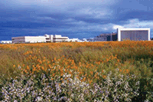
Ames Research Center
Moffett Field, California
Founded in 1939, the NASA Ames Research Center has evolved into one of the nation’s premiere research labs in support of NASA missions and the nation’s Vision for Space Exploration. Located in California’s Silicon Valley, NASA Ames has created partnerships with leading universities and high-technology industry leaders, bringing the scientific and corporate communities together in efforts to advance human knowledge and explore the unknown.

Dryden Flight Research Center
Edwards, California
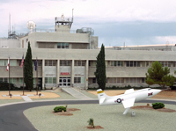
The Dryden Flight Research Center is NASA's primary center for atmospheric flight research and operations. NASA Dryden is critical in carrying out the agency's missions of space exploration, space operations, scientific discovery, and aeronautical research and development (R&D). Located in Edwards, California, in the western Mojave Desert, Dryden is uniquely situated to take advantage of the excellent year-round flying weather, remote area, and good visibility to test some of the nation's most exciting air vehicles.

Glenn Research Center
Cleveland, Ohio
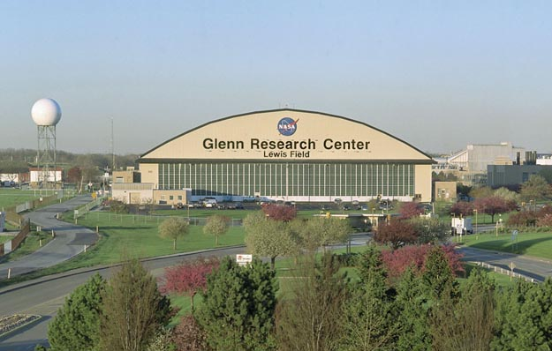
On the shore of Lake Erie, in the birthplace of flight, NASA’s Glenn Research Center advances aviation and space exploration. It specializes in spaceflight systems, propulsion, power, communications, microgravity science, and human research. With its world-class facilities, engineers, and researchers, NASA Glenn is advancing exploration of our solar system and beyond while maintaining global leadership in aeronautics.

Goddard Space Flight Center
Greenbelt, Maryland
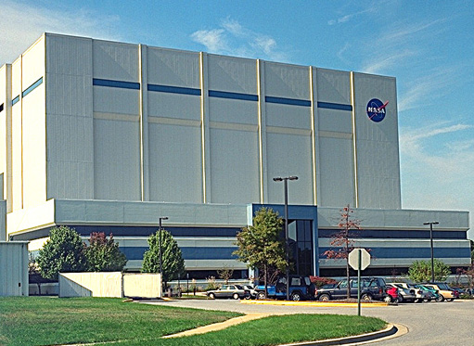
Located outside of Washington, DC, the Goddard Space Flight Center (GSFC) is home to the nation's largest organization of combined scientists and engineers. They are dedicated to learning and sharing their knowledge of the Earth, solar system, and universe. The mission of the GSFC is to expand knowledge of the Earth and its environment, the solar system, and the universe through observations from space. To assure that our nation maintains leadership in this endeavor, the GSFC is committed to excellence in scientific investigation, the development and operation of space systems, and the advancement of essential technologies.

NASA Headquarters
Washington, D.C.
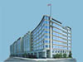
NASA Headquarters, located in Washington, D.C., exercises management over the space flight centers, research centers, and other installations that constitute NASA. The responsibilities of Headquarters include the determination of programs and projects; establishment of management policies, procedures, and performance criteria; evaluation of progress; and the review and analysis of all phases of the aerospace program.

Jet Propulsion Lab
Pasadena, California
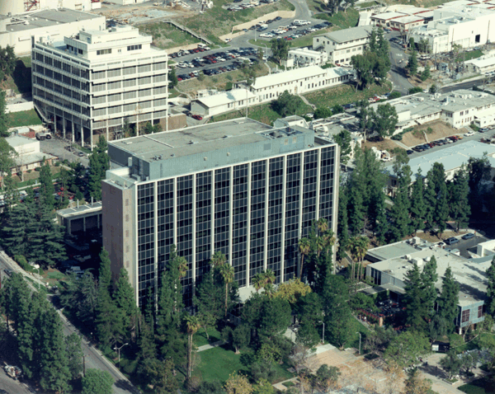
The Jet Propulsion Lab (JPL) was established by the California Institute of Technology in the 1930s. America's first satellite, Explorer 1, was created at JPL. In the decades that followed, JPL sent the first robotic craft to the Moon and out across the solar system, reconnoitering all of the planets. JPL is responsible for the Mars Phoenix Lander, Dawn spacecraft, Mars Reconnaissance Orbiter, and the rovers Spirit and Opportunity. The flagship explorer Cassini continues its orbits of Saturn, scrutinizing the ringed planet and its moons, including the haze-shrouded Titan. The Voyagers are exploring the edge of our solar system.

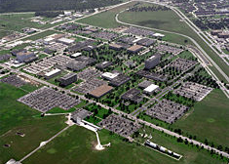
Johnson Space Center
Houston, Texas
From the early Gemini, Apollo and Skylab projects to today’s International Space Station and Space Shuttle Programs, the Johnson Space Center (JSC) continues to lead NASA’s efforts in space exploration by humans. The Space Center Houston, the official visitor center of the Johnson Space Center, shares the thrill and wonder of space exploration with visitors from around the world.

John F. Kennedy Space Center
Cape Canaveral, Florida
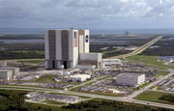
The John F. Kennedy Space Center is located on the golden shores of Florida’s east coast. Its rich legacy includes launching all U.S. human space flight missions. From the early days of Project Mercury to the space shuttle and the next generation of vehicles, the Kennedy Space Center continues to send spacecraft to the farthest reaches of our solar system and beyond. The Kennedy Space Center Visitor Complex is open every day of the year, except December 25 and certain launch days.

Langley Research Center
Hampton, Virginia
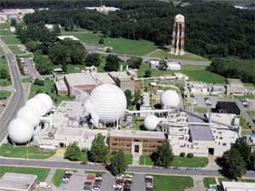
The Langley Research Center continues to forge new frontiers in aviation and space research as it has since 1917, when it was established as the nation's first civilian aeronautics laboratory. Langley's mission and contributions to aerospace, atmospheric sciences, and technology commercialization are improving the way the world lives. While more than half of NASA Langley's research is in aeronautics, its researchers have expanded their studies into other atmospheres, which our spacecraft will find on distant planets. Langley also leads NASA initiatives in aviation safety, quiet aircraft technology, small aircraft transportation, and aerospace vehicles system technology. It supports NASA space programs with atmospheric research and technology testing and development.

Marshall Space Flight Center
Huntsville, Alabama
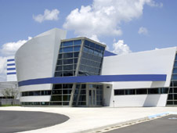
The Marshall Space Flight Center in Huntsville, Alabama, is one of NASA's largest and most diversified installations. Marshall manages the key propulsion hardware and technologies of the space shuttle; develops the next generation of space transportation and propulsion systems; oversees science and hardware development for the International Space Station; manages projects and direct studies that will help pave the way back to the moon; and handles a variety of associated scientific endeavors to benefit space exploration and improve life on Earth. Marshall also develops transportation and propulsion systems, space infrastructure, applied materials and manufacturing processes, scientific spacecraft research and instruments, and large complex systems.

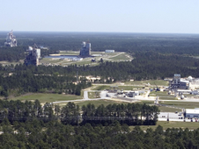
Stennis Space Center
Hancock County, Mississippi
For more than four decades, the Stennis Space Center has served as NASA’s rocket propulsion testing ground. In addition, the Applied Research Technology Project Office bridges the gap between Earth science research results and the use of data to help its partner agencies make better informed decisions. The center contains with more than 30 resident agencies.

NASA Facilities
This information was extracted from http://www.nasa.gov/.

NASA IV&V Facility
Fairmont, West Virginia
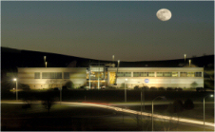
Located in the heart of West Virginia's emerging technology sector, the NASA IV&V Facility was established in 1993 as part of an Agency-wide strategy to provide the highest achievable levels of safety and cost-effectiveness for mission critical software. Since then, the NASA IV&V Facility has experienced continual growth in personnel, projects, capabilities, and accomplishments. The Facility's efforts have contributed to NASA's improved safety record since its inception. The NASA IV&V Facility houses over 150 full-time employees and utilizes the expertise of in-house partners and contractors.

Goddard Institute for Space Studies
New York, New York
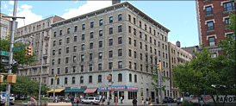
The NASA Goddard Institute for Space Studies (GISS), at Columbia University in New York City, is a laboratory of the Earth Sciences Division of NASA's Goddard Space Flight Center (GSFC). It is also a unit of the Columbia University Earth Institute. Research at GISS emphasizes a broad study of global climate change.
The institute was originally established in May 1961. Much of the institute's early work involved study of planetary atmospheres using data collected by telescopes and space probes, and in time that led to GISS becoming a leading center of atmospheric modeling and climate change.
Wallops Flight Facility
Temperanceville, Virginia
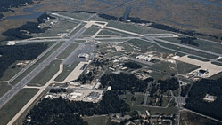
The Wallops Flight Facility, located on Virginia's eastern shore, is NASA's premier site for suborbital and small orbital flight projects, Earth Science research, and technology development. It also is home to NASA's only owned and operated launch range. This Facility was established in 1945 by the National Advisory Committee for Aeronautics as a center for aeronautic research.

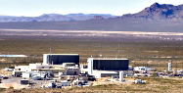
White Sands Test Facility
Las Cruces, New Mexico
The White Sands Test Facility (WSTF) is a preeminent resource for testing and evaluating potentially hazardous materials, space flight components, and rocket propulsion systems. Its services are available to NASA, the Department of Defense, and other federal agencies, universities, and commercial industries.

The primary mission of WSTF is to support NASA's Space Shuttle and Space Station Programs, as well as other government and commercial efforts. As the official Johnson Space Center (JSC) Propulsion Systems Development Facility, its rocket propulsion program is a leader in propulsion systems testing, with unique test expertise in hypergolic propellant handling and training. It also is the Shuttle Fleet Leader for testing orbital maneuvering and reaction control subsystems.

